Wiltshire Cricket Limited Talent Pathway Coach Code of Conduct

SAFEGUARDING:

Introduction

(Wiltshire Cricket Limited takes its role as a provider of cricket for children, young people and adults at risk very seriously. Their wellbeing is paramount in all decisions taken by us. All children and young people we come into contact with have the same protection regardless of age, disability, gender, race, religious belief or sexual orientation.

We act in accordance with legislation, statutory guidance and the ECB Safe Hands Policy and work collaboratively with the ECB / Cricket Regulator in relation to concerns around the safeguarding of children, young people and adults at risk.

To whom does this Code of Conduct Apply?

This Code of Conduct applies to all staff, as safeguarding is everyone’s responsibility. It therefore applies to and is required to be signed by employees, consultants, contractors, casual and agency staff (collectively referred to as staff in this Code of Conduct).

Staff Expectations

It is our expectation that all our staff will always act in the best interests of children and young people under the age of 18 and in accordance with the ECB Safe Hands Policy. The welfare of children and young people must always be paramount. We also expect our staff to act in the best interests of adults at risk in cricket.

This includes an expectation that staff will:

- Undertake safeguarding education or training – including staff induction - as required by Wiltshire Cricket, and ensure that further training remains up to date
- Read and comply with ECB Safe Hands Policy
- Be appropriately vetted if required to do so as specified in Safe Hands
- Act in an appropriate way at all times when in contact with children and young people and adults at risk, whether face-to-face, via social media, phone or by any other electronic communications.
- Recognise the importance of confidentiality when working with children, young people, their families and their data.
- Promptly report any concerns about safeguarding or the protection of children or young people in cricket to the County Safeguarding Officer or Cricket Regulator.
- Be familiar with and use the whistle blowing policy if you suspect or believe that safeguarding concerns have not been appropriately addressed by Wiltshire Cricket Limited. (Contact: safeguarding@cricketregulator.co.uk / 020 7432 1200)
- Accept that, by working in your role, you are in a position of trust with under-18 participants that you are in contact with.
- Listen to any concerns that parents or young people might have
- Champion everyone's right to take part in Cricket and celebrate differences in our community by not discriminating against anyone, regardless of gender, race, sexual orientation or ability
- Comply with any safeguarding initiatives in place by Wiltshire Cricket
- Attend training deemed mandatory by Wiltshire Cricket and/ or the ECB / Cricket Regulator
- Act with integrity at all times.
- Proactively seek advice from the County Safeguarding Officer or Cricket Regulator if required.

As a member of our staff, we understand you have the right to:

- Enjoy the time you spend working for Wiltshire Cricket and be supported in your role
- Be informed of our safeguarding and reporting procedures and what you need to do if something isn't right
- Have access to ongoing training in all aspects of your role
- Be listened to
- Be respected and treated fairly by Wiltshire Cricket Limited
- Feel welcomed, valued and not judged based on your race, gender, sexuality or ability

Further information and support

Further safeguarding information is available in Safe Hands.
- County Safeguarding Officer: iestyn.lewis@wiltshirecricket.co.uk / safeguarding@wiltshirecricket.co.uk
- Cricket Regulator: safeguarding@cricketregulator.co.uk

If you have any queries or concerns regarding the Code of Conduct or safeguarding generally, please speak to the Wiltshire Cricket Limited County Safeguarding Officer in the first instance.

YOUR ROLE AS A TALENT PATHWAY COACH:

The section of the code of conduct is an extension of the ECB Coaches Code of Conduct (which we expect all coaches and managers to adhere to) and it applies to all Coaches and Managers who are appointed to work on Wiltshire Cricket Talent Pathway programmes:

Expected standards of behaviour and conduct:

*These standards of behaviour and conduct, as well as those contained within the ECB Coaches of Conduct, apply in all scenarios regardless of whether the coaching is being undertaken on behalf of Wiltshire Cricket or another organisation (e.g. club or school)

- Alignment to Wiltshire Cricket Talent Pathway Framework – We expect coaches working on behalf of Wiltshire Cricket to align coaching sessions, management of matches and selection decisions to the principles outlined in the Wiltshire Cricket Talent Pathway Framework and associated Skills Framework videos.
- Communication – Particularly following trials and/or matches, coaches may be asked to give feedback to players or parents on selection decisions. We expect coaches to respond politely and professionally to these requests for feedback and to be prepared to give feedback as objectively as possible and aligned to the Talent Pathway Framework above.
- Relationships - Ensure that when in a position of authority this privilege will not be used to exert influence over participants to gain personal benefit for themselves, their clubs or their schools
- Social Media – Be aware of responsibilities as a Wiltshire Cricket representative when using social media. Any work-related issues or personal views which could adversely affect Wiltshire Cricket must not be placed on your private social network accounts
- Clothing – When working on behalf of Wiltshire Cricket, coaches should wear Wiltshire Cricket branded clothing
- Role Models – As a Wiltshire Cricket coach, be aware of promoting the reputation of Wiltshire Cricket and take all possible steps to prevent it from being brought into disrepute, for example by:
  - Accepting success and failure, victory and defeat, with dignity
  - Setting a positive example for players, parents and spectators by role modelling respect for opponents, officials and host clubs

WILTSHIRE CRICKET VALUES:

We expect our Talent Pathway coaches to operate in line with Wiltshire Cricket’s Company Values:

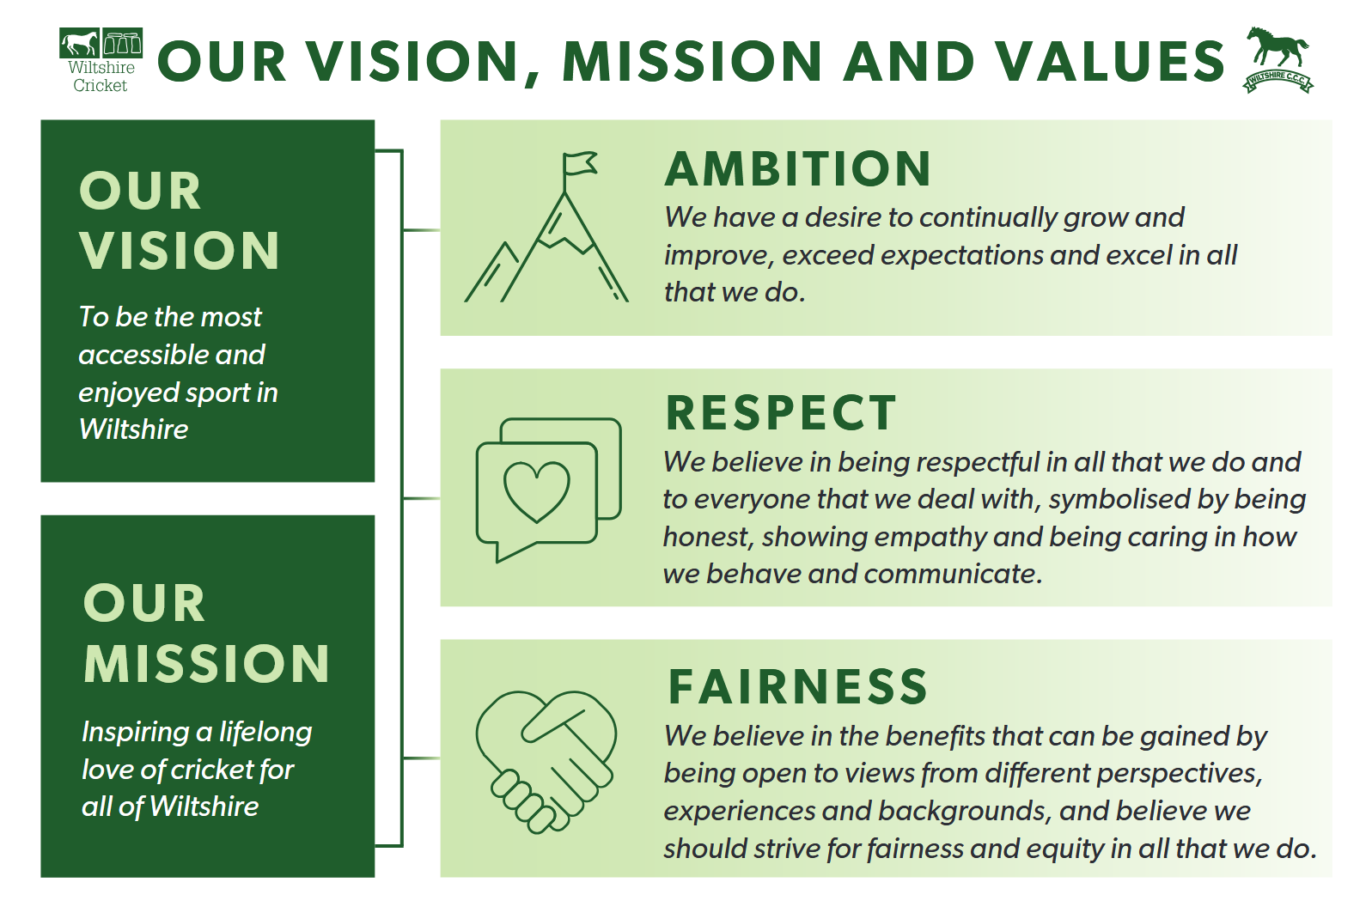

ANTI-DISCRIMINATION:

Tackling discrimination and promoting greater inclusion and diversity across the game is a priority as we strive to stamp out any form of discrimination and to make the game more inclusive and diverse.

We therefore ask our coaches to play an active role in making Cricket a game for everyone by reading the items in the link above and by noting that Wiltshire Cricket is fully signed up to the ECB Anti-Discrimination Regulations.

DISCIPLINARY PROCESSES

In the event that either the ECB code of conduct or any of the contents above are not adhered to, coaches will be bound by the General Conduct Regulations and / or the Wiltshire Cricket Limited Disciplinary processes.

